Ricardo Jacome

MECH 875 - Mechanical Vibrations

Professor: Dr. Joseph Turner

**Vibration Measurements on Steering Wheel Maneuvering**

**Abstract**

The objective of this report is to offer a cost-effective solution for measuring steering wheel angles with noise due to vibrations in a vehicle. Traditionally, on car-crash testing there is not recordings of the steering wheel angles due to sensors getting damaged. A solution proposed to this problem is to use a wireless measurement device that broadcasts steering wheel data during vehicle testing. The resulting data is then filtered and analyzed to separate the noise measurements due to vibrations and the steering wheel data. From the results, the effectiveness of this method is evaluated, and future car-crash applications are discussed.

**Introduction**

When measuring accelerations or angular rates in vehicles, vibrations from the road contribute noise to the measurements. During car-crash testing, vibrations due to impact become an obstruction to interpret data and often require heavy duty measurement devices. Furthermore, these devices need to be attached to a section that has the least damage to avoid malfunctions. For this reason, obtaining steering wheel angles becomes a task almost impossible during car-crash analysis. In this project, a disposable sensor is used to investigate the effectiveness on recording steering wheel angles during vehicle maneuvering. The outcome of the project would be to determine feasibility of this sensor in car-crash testing analysis. This will be determined by identifying steering wheel angles during cornering.

The first section offers a Background Study on the subject. Secondly, an instrumentation section offers details of the specifications in the sensor along with the experimental setup. Third is the results and analysis that are found from the experiment. This analysis includes signal processing and response characterization of the system. Finally, a summary of conclusions and recommendations is offered for future research.

**Background**

Signal Processing is used to filter out noise or unwanted information that sensors record. This noise can be present due to the electric components within it, and from exterior sources as well. These exterior sources can include many parameters depending on what is being measured. On the case for this experiment, the noise source will come primarily from road vibrations. For this reason, it is necessary to find a way to distinguish in between noise data and relevant sensor measurements. To illustrate this concept, a sample time domain signal is shown in Figure 1. This graph shows a “clean” sine signal that has no disturbances to it.

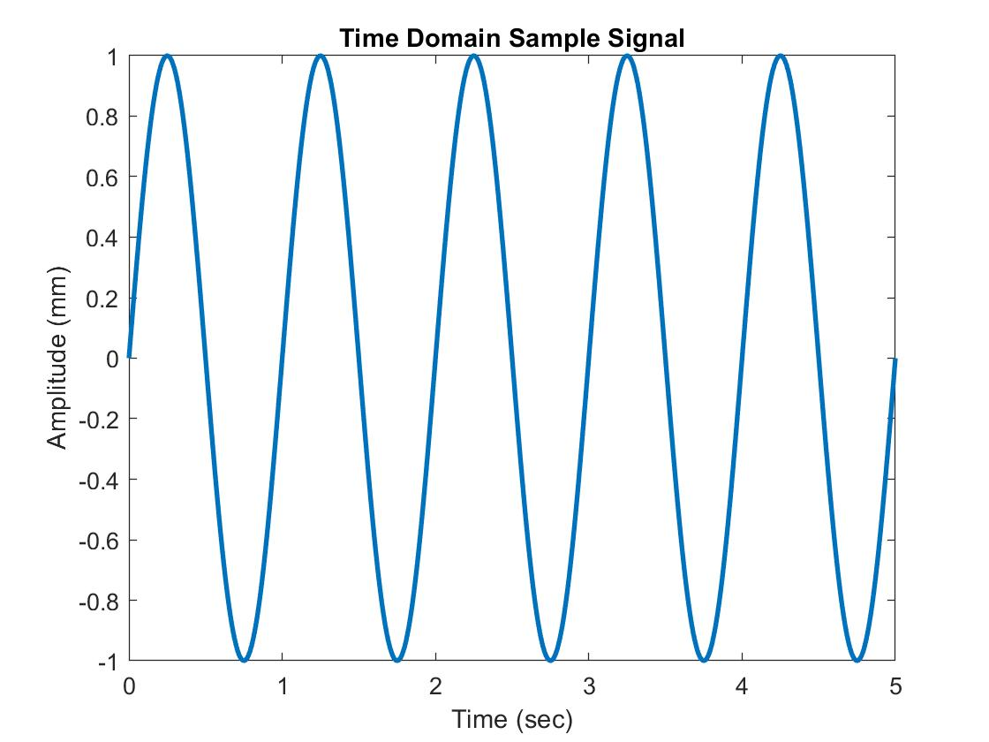

Figure 1.- Time Domain Sample Signal

The next step is to perform a Fast Fourier Transform (FFT) to convert the time domain signal into a frequency domain one which is illustrated in Figure 2. This Figure shows only one peak which denotes the frequency content of the time domain signal. This is expected because the time signal has no other disturbances on it.

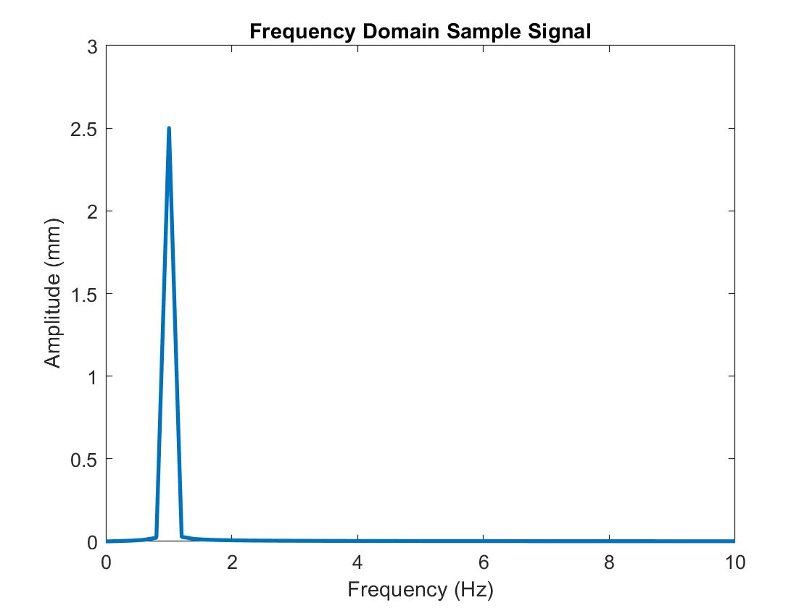

Figure 2.- Frequency Domain Sample Signal

When a time signal has noise, it can be denoted to be the superposition of many sine waves together that at first glance do not seem meaningful to interpret data. In this case, an FFT would show all the frequency content of each individual wave that composes the noisy signal. Through this, it will be possible to remove all unnecessary data and obtain only relevant information about the time signal. An example is shown in Figure 3 that illustrates the same time signal with noisy along with its frequency content.

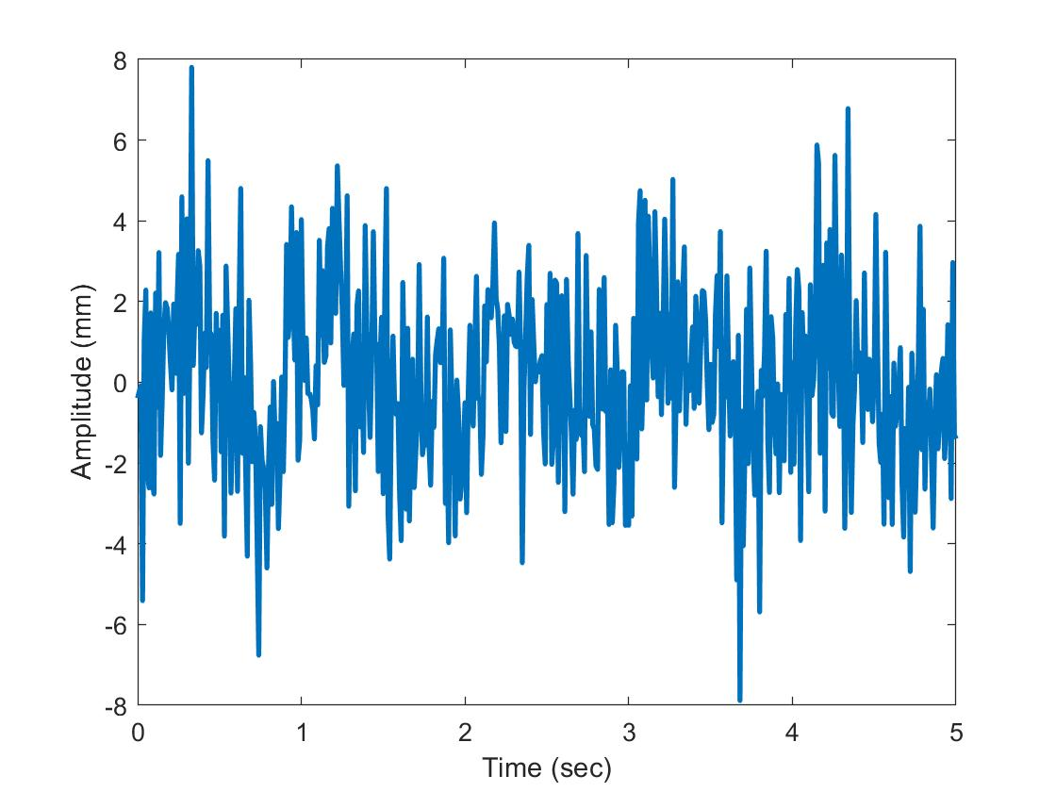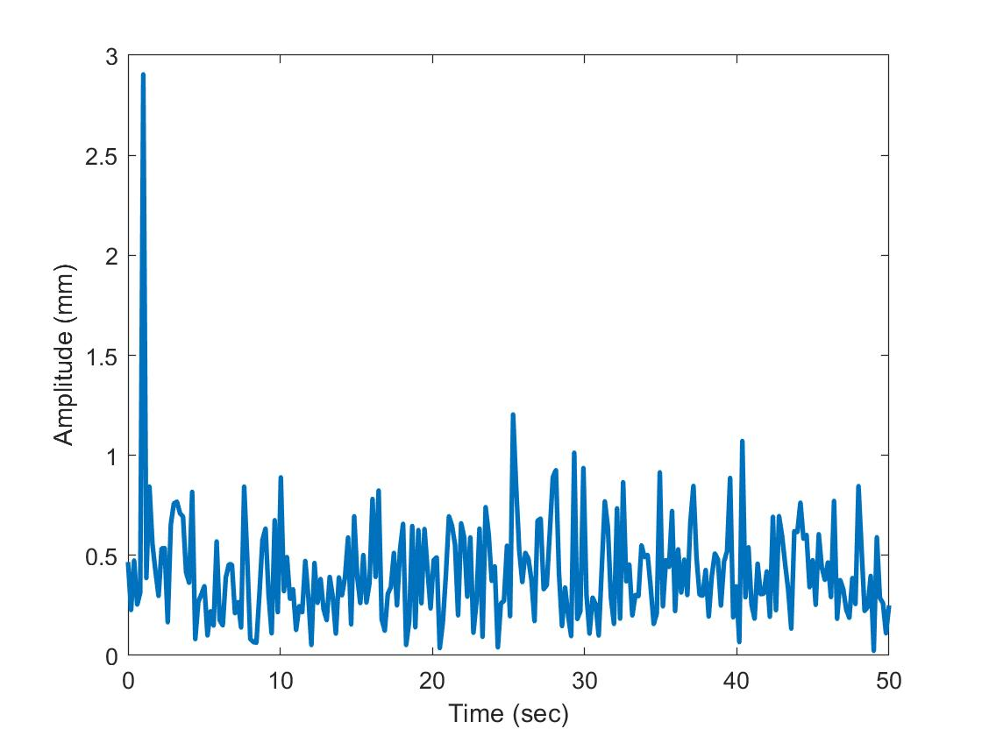

Figure 3.- Noisy Time Domain Sample Signal (left) and Noisy Frequency Sample Signal (right)

In Figure 3 it is noticeable that the frequency content still shows the same peak as the clean frequency signal. This provides us with frequency information that it is easier to find than what the time signal shows. The same procedure will be used to analyze the steering wheel behavior of a vehicle under road vibrations.

**Instrumentation and Testing Setup**

*Sensor Parameters/Conventions and Setup*

To measure the steering wheel angles, a Witmotion BWT61CL Sensor is used. This sensor contains a JY61 Gyroscope, a 150mAh lithium battery, and Bluetooth Transmitter. The sensor specifications are summarized on Table 1, and a sample image of the sensor is presented on Figure 1.

Table 1. Witmotion BWT61CL Sensor Specifications

|  |  |  |  |
| --- | --- | --- | --- |
| Parameter | Quantity | Parameter | Quantity |
| Voltage | 3.3 V – 5V | Current | < 40mA |
| Accelerated Speed Range | $±$ 16g’s | Angular Speed Range | $±$ 2000 $°$/s |
| Angle Range | $±$ 180 $°$ | Measurement Stability | 0.05 $°/s$ |
| Output Frequency | 100 Hz | Baud Rate | 115200 pulse/s |
| Transmission Distance | <10 m | Date Interface | Serial TTL Level |

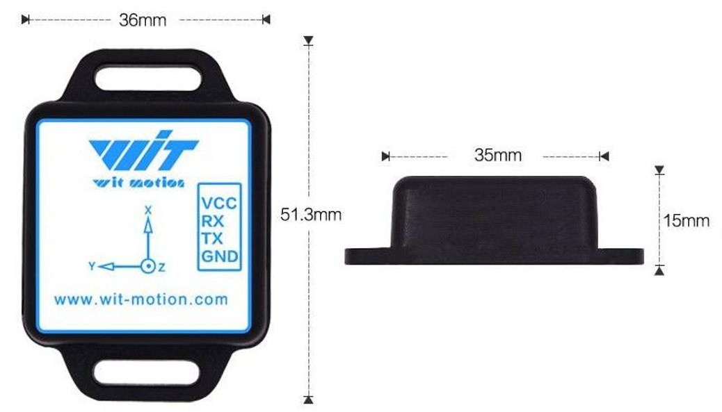

Figure 1 – Witmotion BWT61CL Sample Image with Dimensions

The Witmotion Sensor has an angle convention that needs to be understood for data analysis. As shown in Figure 2, after rotating the sensor 180 $°$ from equilibrium position, it will start counting on the negative 180 $°$ until it reaches a full revolution and it will start at zero again. This behavior is the same for both counterclockwise and clockwise directions.

0 $°$



+180 $°$

-180 $°$

Figure 2- Sensor Angle Conventions

This sensor communicates with an Android device where the information is sent and stored. To perform this experiment, a Nissan Altima 2014 as shown in Figure 3, is used. The sensor is zeroed at the center of the steering wheel, and then attached with high tension bands to allow for higher displacement transmissibility in between the sensor and the steering wheel as shown in Figure 3.

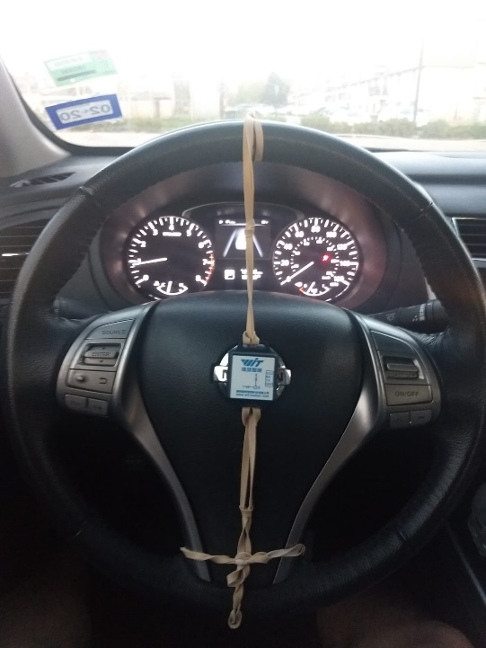

Figure 3 – Test Vehicle and Sensor Positioning in Steering Wheel.

*Testing Scenarios*

The test took place in 2 different scenarios which consisted of a typical concrete street and one with a rough dirt terrain and uneven surfaces as shown in Figures 4 and 5. Each scenario was repeated twice to provide with repeatability giving a total of four different tests. The driving conditions consisted of first straight up driving followed by a right turning, driving straight up again and perform a left turn before stopping. The driver tried to commit to an average velocity of 20 mph before turning, maintaining a straight line and perform a full braking. The time was around 1 minute per test, and vehicle trajectories are shown in Figures 4 and 5.

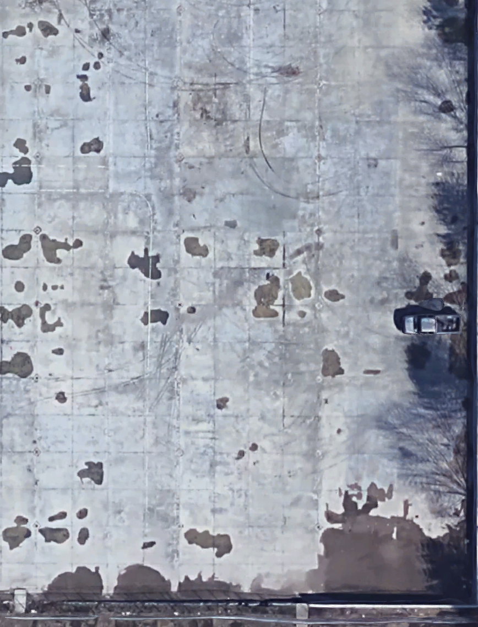

Figure 4 – Concrete Testing Scenario: Front View (Left Image), Satellite View (Right Image)

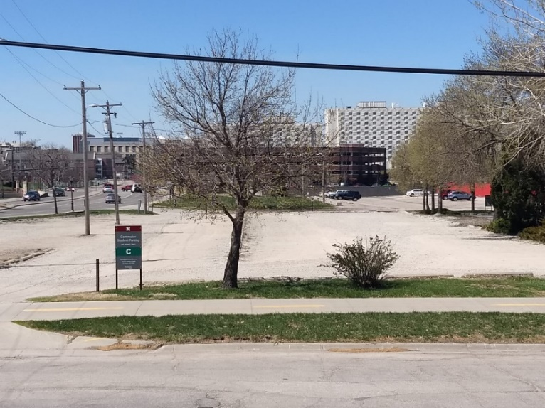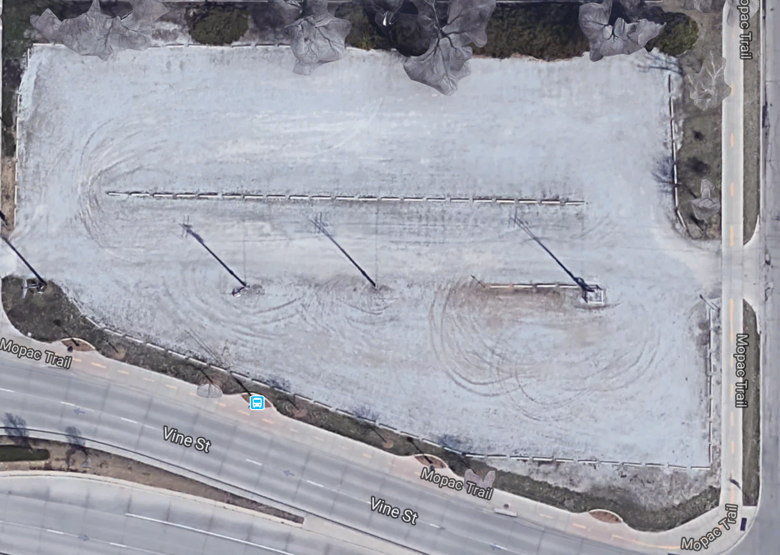

Figure 5 – Dirt Testing Scenario: Front View (Left Image), Satellite View (Right Image)

**Results and Analysis**

*Acceleration Data*

The results provided from the experiment will be discussed. As expected from a wireless sensor, the resolution was low on accelerations as shown in Figures 6 & 7. The accelerations from the Dirt Road (Tests 3 and 4) were noisier than the Concrete Road (Tests 1 and 2). Accelerations on the Z direction showed to be the noisier up to the point where the trace is not recognizable anymore. For this, frequency analysis will be performed in the next section. Accelerations on X and Y even though are noisy, do not show difficulties to trace signal information. The significance of Acceleration waveform not being the same for the Concrete and Dirt road cases is due to the sharpness of the curve the driver took during maneuvering. Since the turning on Tests 3 and 4 was sharper, the direction of the steering wheel had more turns than Tests 1 and 2. However, successful readings are acquired from both cases in Accelerations for X and Y.



Figure 6 –Acceleration Readings for both Flat and Rough Roads

*Steering Wheel Data*

Resolution was not an issue for steering wheel data as is shown in Figure 7. Given that none of the angles had resolution issues, no frequency analysis will be performed on these data sets. The steering angle about the Z axis with respect to the steering wheel proves to be the most meaningful in terms of steering behavior. As it is shown in the Steering Angle about Z on Figure 7, the data shows how a sharper turn occurs during Tests 3 and 4, compared to that of Tests 1 and 2.





Figure 7 –Steering Readings for both Flat and Rough Roads

*Frequency Analysis*

For this section, a Fast Fourier Transform (FFT) was utilized on the noisy acceleration data. The results from the FFT are shown in Figure 8. Frequency content of the signals show similar frequencies for all tests. In the case of the noisiest acceleration, it can be noted how the FFT yields a very similar frequency for all tests. Therefore, information extracted from Tests 1 and 2 can serve as representative of Tests 3 and 4.



Figure 8 –Fast Fourier Transforms from Steering Angle Data

**Conclusion**

From the results, it can be concluded that utilizing the Witmotion sensor provides useful steering data that can be analyzed even in the case of disturbances such as a rough road profile. The resolution of acceleration data was not high, but it was enough to extract steering wheel accelerations. FFTs proved to be efficient in extracting frequency data from the noisy experiments. Also, the resolution was high enough to obtain a precise steering wheel maneuvering plot even with the presence of noise.